Grade 1 Music Theory Helpsheet
  - What you need to know:
- Note values of semibreve, minim, crotchet, quaver and semiquaver, and their equivalent rests (candidates may use the terms ‘whole note’, ‘half note’, etc.). Tied notes. Single-dotted notes and rests.
- Simple time signatures of 2/4, 3/4 & 4/4, bar-lines and the grouping of the notes listed above within these times.
- The stave. Treble (G) and bass (F) clefs. Names of notes on the stave, including middle C in both clefs. Sharp, flat and natural signs, and their cancellation.
- Construction of the major scale, including the position of the tones and semitones. Scales and key signatures of the major keys of C, G, D and F in both clefs, with their tonic triads (root position), degrees (number only), and intervals above the tonic (by number only).
- Some frequently used terms and signs concerning tempo, dynamics, performance directions and articulation marks. Simple questions will be asked about a melody written in either treble or bass clef.

  - Note Values:
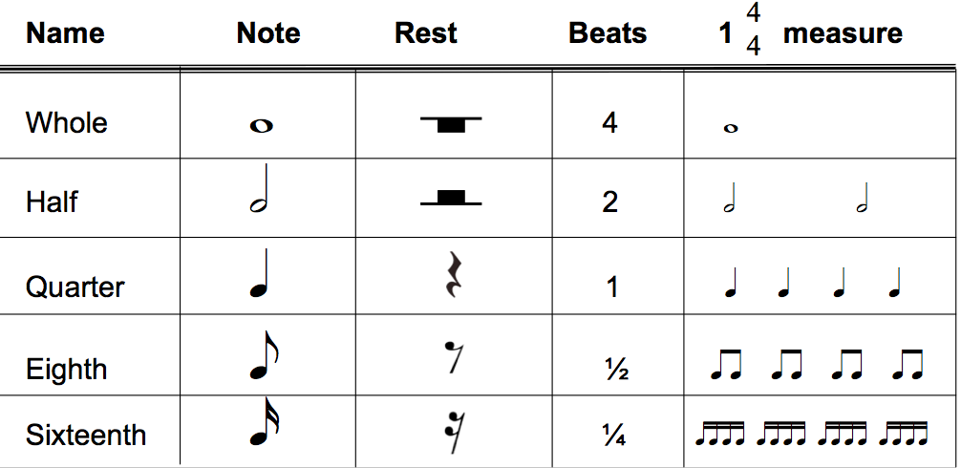
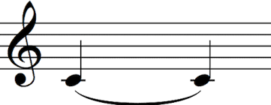
Tied notes- the notes should be played together, without a break. The length you need to hold it for is equal to the length
of the individual notes added together.

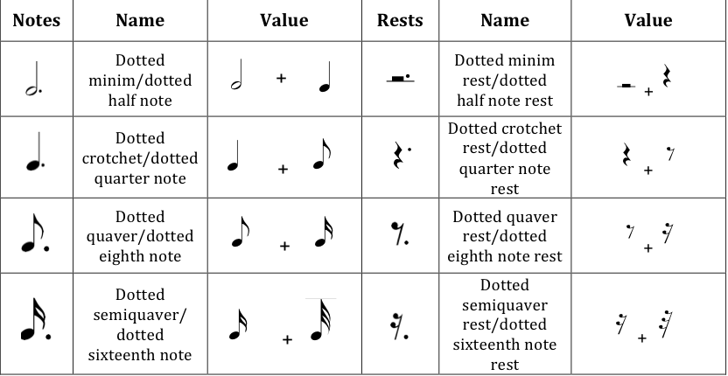

  - Time Signatures:

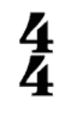
What note represents one beat (eg: this means crotchets)
How many beats in a bar

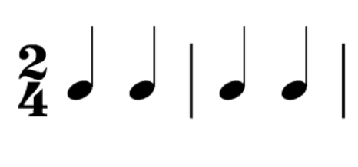
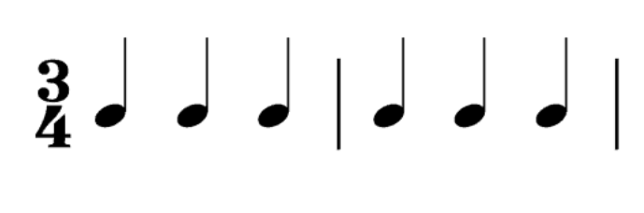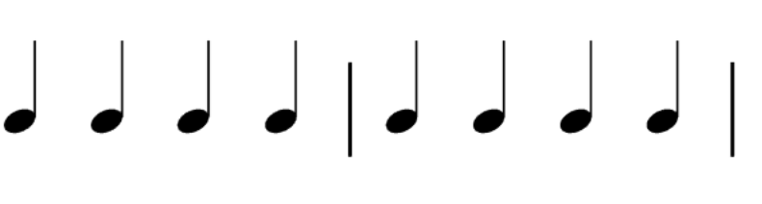
This is a bar-line. It is used to separate bars

  - The Stave and Clefs:

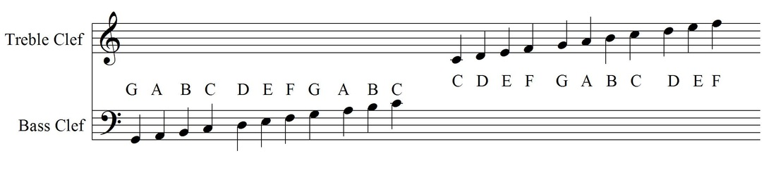
Middle C

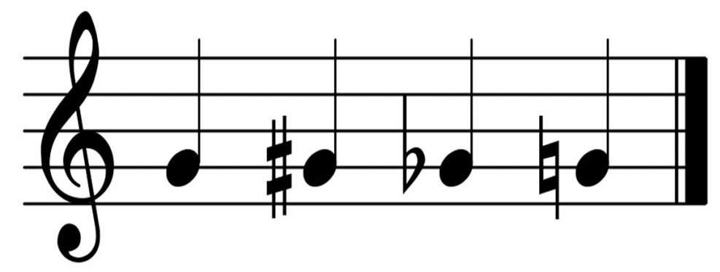
Sharp Flat Natural

  - Major Scales:
C Major
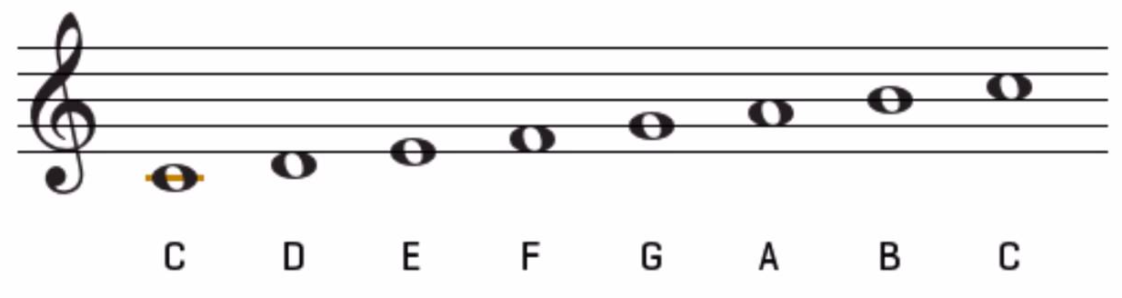
T T ST T T T ST

T- Tone
ST- Semi-tone

G Major

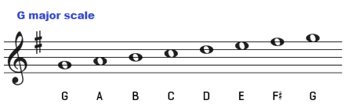
I II III IV V VI VII VII/ I
D Major

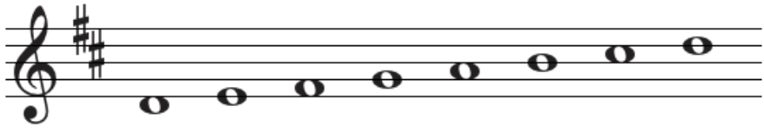
I II III IV V VI VII VII/ I

F Major

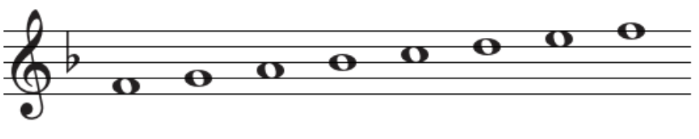
I II III IV V VI VII VII/ I

  - Frequently used Terms and Signs:
  - 